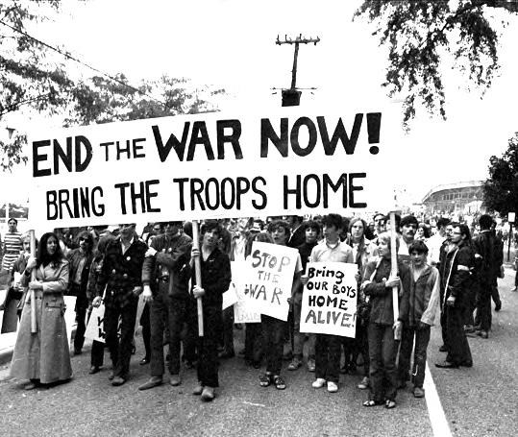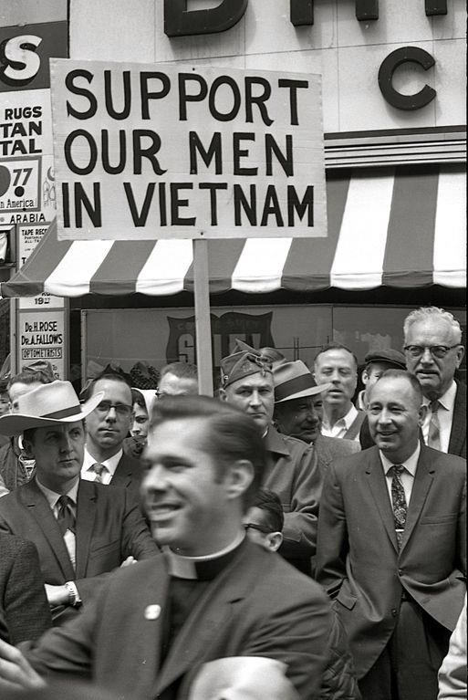
Analyzing Resistance, Collaboration,

&
Neutrality

in

the
Vietnam War Era

Directions
:

The
Vietnam War era

was one
of the most
tumultuous
times in American
History
. It was the first wa
r that truly
divided the nation and saw countless
protests movements rise up

against
America
’
s involvement in Vietnam.

At the
same time, many Am
ericans supported the
war and saw it as the US standing up to
communism and helping an oppressed
people.

You are going to analyze several key events
from the
Vietnam War era
. For each one,
you have to place yourself in the time period
and make a choice on how you would
respond. Would you:

1.

Resist

2.

Collaborate

3.

Act as if nothin
g
happened

If you choose to
resist
, you are joini
ng those
protesting against
American actions in Vietnam
.

Collaborating

means supporting
the American
war effort in Vietnam
.

Fina
l
l
y
, you could choose to ignore the events
going on
and
act as if nothing had ha
ppened
.

After reading about each

event,
write in the date
that it occurred and
take several
minutes to think
about how you would respond and the
repercussions that decision might have.

After you have decided
,
circle your response and
briefly describe your reasoni
ng
.

Name _________________________________________
Analyzing Responses in the Vietnam War Era
Event | Date | Response | Reasoning
First American  Deaths in  Vietnam |  | Resist  Collaborate  Ignore
Thích Quång Dúc  Burns Himself to Death |  | Resist  Collaborate  Ignore
The Gulf of Tonkin  Resolution |  | Resist  Collaborate  Ignore
Public Opinion of the War Drops |  | Resist  Collaborate  Ignore
Tet Offensive |  | Resist  Collaborate  Ignore
The My Lai Massacre |  | Resist  Collaborate  Ignore
Kent State Shootings |  | Resist  Collaborate  Ignore
Pentagon Papers Published |  | Resist  Collaborate  Ignore

Analysis Questions
Which event had the biggest impact on you and why?

How did your responses to the events change over time?

Given the events that took place during this era and in today’s world, what does it look like when people:
Resist | Collaborate | Act as if nothing is happening

What impact can that choice have on you as an individual and on those around you?

First American Deaths in Vietnam
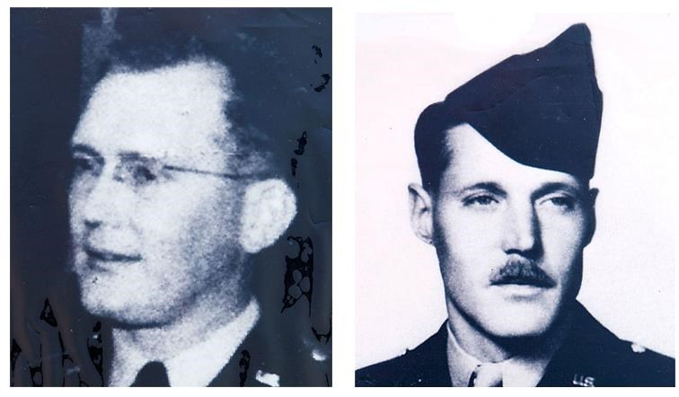
In 1955, America began sending military advisors to South Vietnam to help prevent a communist takeover by the North Vietnamese government, which sought to unify Vietnam. On July 8, 1959, two military advisors (Maj. Dale
Ruis & Sgt. Chester Ovnand) were killed by Viet
Minh guerilla soldiers in a raid at Bien Hoa in South Vietnam. These were the first American deaths reported in Vietnam’s conflict.
Decision: Would you join the resistance and protest US involvement in Vietnam, collaborate with and support the US government’s actions in Vietnam, or act as if nothing had happened?

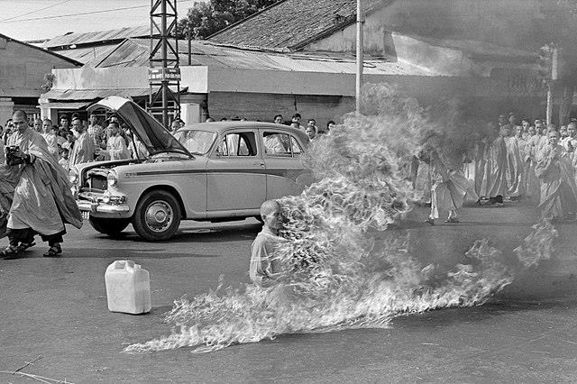
Thi
ch Q
ua
ng Du
c Burns Himself to Death

On
June 11, 1963
,

a South Vietnamese Buddhist
Monk named

Thích Qu
ả
ng Đ
ứ
c

set himself on
fire at a busy intersection in Saigon to protest the
South Vietnamese government
’
s treatment of
Buddhists.

At the time, Buddhists made up about 80% of
South Vietnam.
Ho
wever,

its
president
Ngô

Đình
Di
ệ
m

was
Catholic and enacted
discriminatory

favoring Catholics for public service and military
promotions, as well as in the allocation of land,
business arrangements and tax concessions
.

In May, 1963, Buddhists were banned from flying
their flag during a holiday and during a protest of the ban, government forces fired into the crowd, killing 9 people. President Diệm blamed the Viet Cong
On June 11, about 350 monks and nuns marched with banners printed in both English and Vietnamese. They denounced the Diệm government and its policy towards Buddhists, demanding that it fulfill its promises of religious equality
John F. Kennedy said about a photograph of Đức on fire, “No news picture in history has generated so much emotion around the world as that one.”
Decision: Would you join the resistance and protest US involvement in Vietnam, collaborate with and support the US government’s actions in Vietnam, or act as if nothing had happened?

The Gulf of Tonkin Resolution
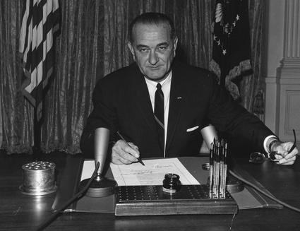
On August 2 & 4, 1964, two US Navy ships were stationed in the Gulf Tonkin, a body of water adjacent to Vietnam. They reported being fired upon by North Vietnamese patrol boats. In response, President Lyndon Johnson requested permission from Congress to increase America's military presence in Vietnam. On August 7, 1964, Congress passed the Gulf of Tonkin Resolution, authorizing the President to take any measures necessary to retaliate and promote peace and security in southeast Asia.
Decision: Would you join the resistance and protest US involvement in Vietnam, collaborate with and support the US government’s actions in Vietnam, or act as if nothing had happened?

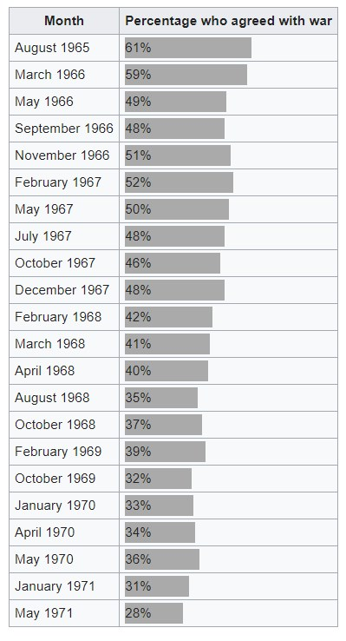
Public Opinion

of the War Dips

Public support for the
Vietnam War

decreased as the war
raged on throughout the sixties and beginning part of the
1970
s.

William L. Lunch and Peter W. Sperlich collected public
opinion data measuring support for the war from 1965 to 1971.
Support for the war was measured by a nega
tive response to
the question:
“
In view of developments since we entered the
fighting in Vietnam
, do you think the U.S. made a mistake
send
ing troops to fight in Vietnam?
”

Over 60% of Americans supported involvement when the
survey was first begun in 1965. Ho
wever,
in

July 1967

that
percentage had dipped below 50%. For the first time, more
Americans disagreed with the war than supported it.

Decision
:

Would you
join the resistance and
protest US
involvement in Vietnam
, collaborate with

and support

the US
government
’s actions in Vietnam,

or act as if nothing had
happened?

The Tet Offensive
The Tet Offensive was a series of over 100 coordinated attacks by North Vietnamese forces on South Vietnam. The attacks took place on January 30, 1968 which marked the Vietnamese New Year, known as the Tết.
The attacks were intended to spark rebellions in South Vietnam against US forces and encourage the US to scale back its involvement. While the attacks stunned US and South Vietnamese forces, they were able to defend all the areas hit and relatively few South Vietnamese were inspired to rebel.
The offensive was a military defeat for North
Vietnam. However, it had a profound effect on the American public, which had been led to believe by political and military leaders that the North Vietnamese were being defeated and incapable of launching such an ambitious military operation.
Further shocking the American public was footage of a South Vietnamese officer executing a handcuffed Viet Cong prisoner on the streets of Saigon.
Decision: Would you join the resistance and protest US involvement in Vietnam, collaborate with and support the US government’s actions in Vietnam, or act as if nothing had happened?

The My Lai Massacre
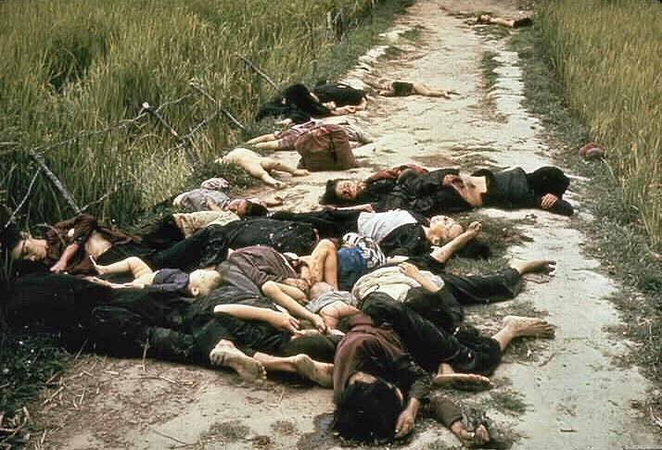
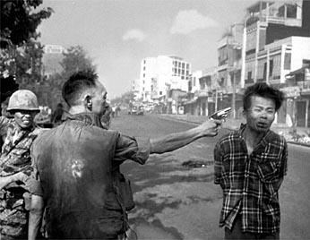
On March 16, 1968, a group of US Army soldiers committed what was later called “the most shocking episode of the Vietnam War” in a small village known as My Lai. It is estimated that over 400 men, women, and young children were killed. The massacre only ended after Army helicopter pilot Hugh Thompson landed between the soldiers and the retreating villagers and threatened to open fire if they continued their attacks. Three other US servicemen who tried to stop the massacre and rescued hiding civilians were shunned and denounced as traitors.
Army officers covered up the massacre for a year until it was reported in the press in November 1969, sparking outrage across the US. The brutality of the My Lai killings and the cover-up fueled anti-war sentiment and further divided the United States over the war. Twenty-six soldiers were charged with criminal offenses, but only platoon leader Lieutenant William Calley was convicted. He was found guilty of killing 22 villagers and given a life sentence, but he served only three and a half years under house arrest.
Decision: Would you join the resistance and protest US involvement in Vietnam, collaborate with and support the US government’s actions in Vietnam, or act as if nothing had happened?

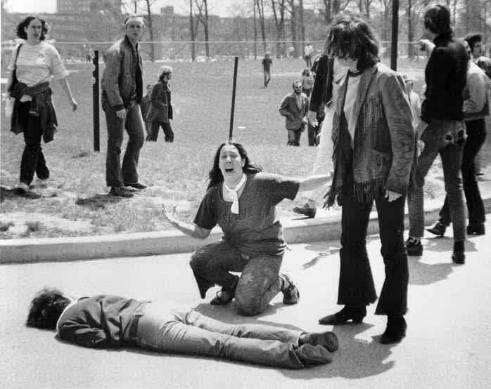
Protests against the Vietnam War were taking place on college campuses across the US since Richard Nixon was elected president, promising to end the War. The military draft changed to a lottery system in December 1969 and eliminated some deferments, affecting many college students. Still, the war still appeared to be winding down in 1970. However, in April 1970 President Nixon announced the Cambodian Campaign which many Americans saw as an expansion of the war by sending troops into another country.
The
Kent State
Shootings

On May 1, 1970, a protest began at Kent State University in Ohio. The following day, the campus ROTC (a campus organization for training future servicemen) building was set on fire and the Ohio National Guard arrived. While students were protesting on campus on May 4, 29 Ohio National Guardsmen fired on the crowd, killing four students and wounding nine others.
Decision: Would you join the resistance and protest US involvement in Vietnam, collaborate with and support the US government’s actions in Vietnam, or act as if nothing had happened?

The Pentagon Papers Published
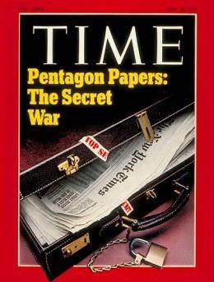
In the 1960's, a top-secret Department of Defense study of America's political and military involvement in Vietnam since 1945 was produced. This came to be known as the Pentagon Papers. Daniel Ellsberg was a military analyst who worked on the study. Initially, he had supported the war, but as the war dragged on, he came to oppose the war and thought the government was lying to the public about the war. He decided that the information contained in the Pentagon Papers should be made public and secretly photocopied portions of it. In March 1971, he gave his copies to The New York Times, which then published a series of scathing articles based on the report’s most damning secrets.
The Papers showed that the Johnson Administration “systematically lied, not only to the public but also to Congress.” They also revealed that the US had secretly enlarged the scope of its actions in the War with bombings of nearby Cambodia and Laos, coastal raids on North Vietnam, and Marine Corps attacks, none of which were reported in the media.
Decision: Would you join the resistance and protest US involvement in Vietnam, collaborate with and support the US government’s actions in Vietnam, or act as if nothing had happened?

Analyzing Resistance, Collaboration, & Neutrality In the Vietnam War Era
Teacher Notes
You can access a Google Docs version of this lesson by clicking here. The Google Docs version uses both online sources for students to research and the printable readings here.
Before starting the lesson, I think it’s important to review the meanings of “resist” and “collaborate”. I use the example of a school rule that students disagree with (there’s always a few that they are adamant about) and how students could “resist” it, “collaborate” with the school administration, or just ignore it.
For the lesson itself, I cut up the readings along the line and place students into groups of 3-4 with a folder of the readings. I think it is important to go through the events in order. While a station activity might seem to work, I avoid doing that because it means starting students at different stations so it won’t go in order.
I stress to students a few things: 1) go through the events in order; and 2) really think about their decision before writing it down. I play songs from the Vietnam War era and say they should never work on more than 1 event in the span of one song (so no less than 3-5 minutes per event). I move around the room to assist students and ensure they are not working too quickly.
After all students have completed all the readings, I have them return to their table groups to talk about their responses and have some students share so we can have a brief class discussion.
Finally, they complete the second page based on the readings and our class discussion.
Obviously, every response will vary widely so there is no “key” possible for the chart. The final questions on the worksheet make for great class discussions and ways to connect to current events and protests that might be going on across the world.
Here are some additional resources you might enjoy for teaching about the Cold War and Civil Rights:
