Containment in Korea & Vietnam
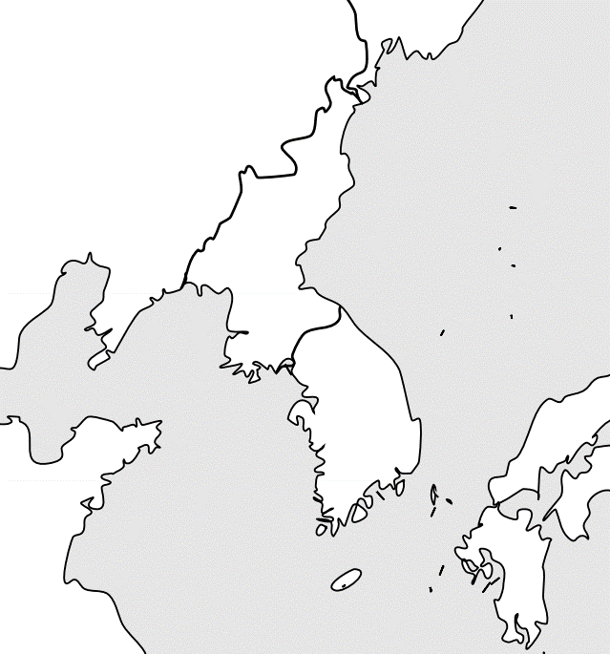
Korea
Before World War 2
- ________________________________

- _________________________________

After World War 2
- ________________________________

- _________________________________

The Korean War
- ________________________________

- ________________________________

- ________________________________

Douglas MacArthur
End of the War
- ____________________________

- ____________________________

- ____________________________
- Leads ________ and _________ forces
in Korea
- Wants to use __________________ on North
Korea & China
- Disobeys ___________________ orders and
is relieved from duty
Vietnam
- Communist _______________ Vs. Democratic _______________
- Ho Chi Minh leads _______________ (North’s army)
- ___________________ warfare examples:

The Vietnam War at Home
- Many ____________ against the war, ______________, and _____________ campaigns
- Violence at protests at _________________________ in 1970
- Makes the war extremely ____________
Terms to Know
- _______________________________ – authorizes Pres. Johnson to escalate the war
- _______________________ – Vietcong surprise attack
- _________________ – President Nixon’s policy to end the war by withdrawing troops
The Paris Peace Agreement
- In 1973, ________________ convinces ________________ that they would not abandon them if they signed a peace accord
- Open ________________ end between the US and __________________________
- ________________ continued as South Vietnamese battled the Communists
- In 1975, ________________ fell and Vietnam was united under ________________
Comparing the Conflicts
The Korean War The Vietnam War

